**CA4 report b10505057**

**Problem 1**

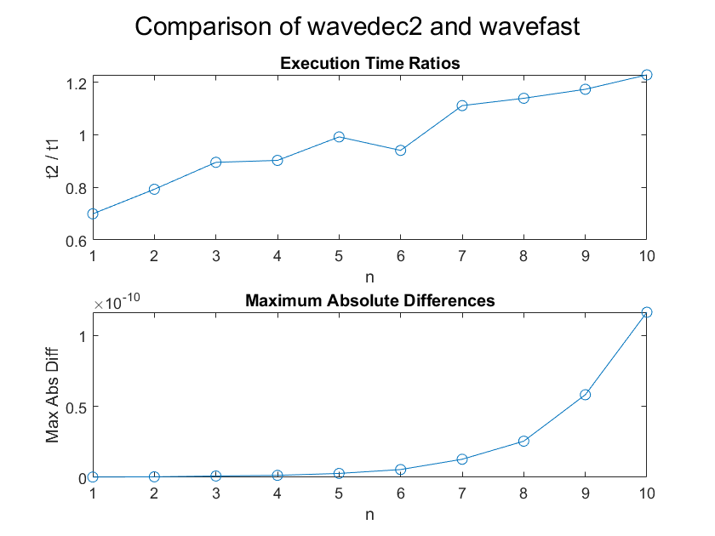

**Problem 2**

1. Default

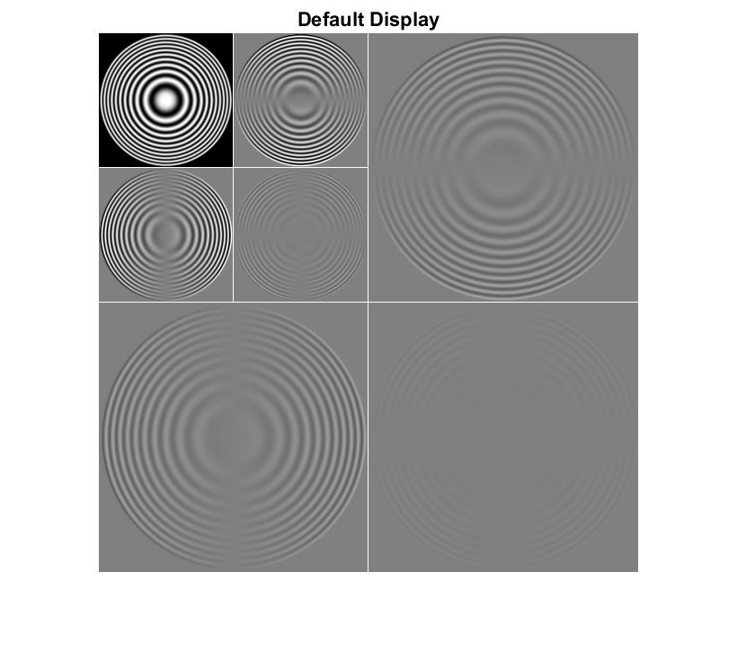

1. Magnify default by scale of 8

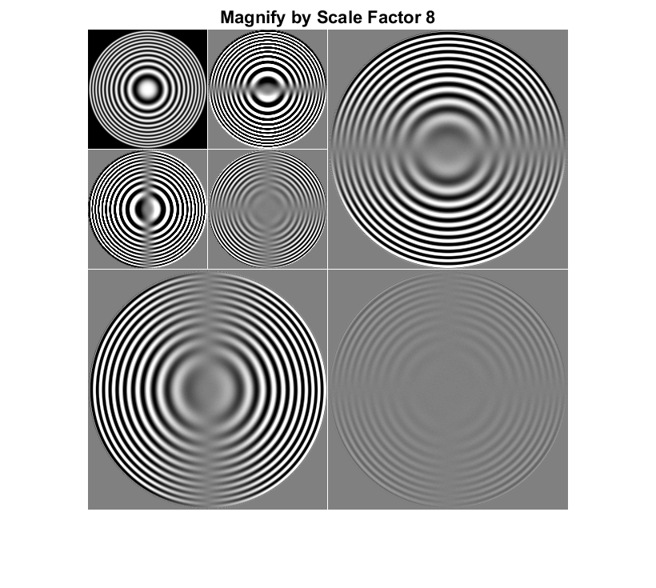

1. Magnify absolute values by abs(scale) with scale

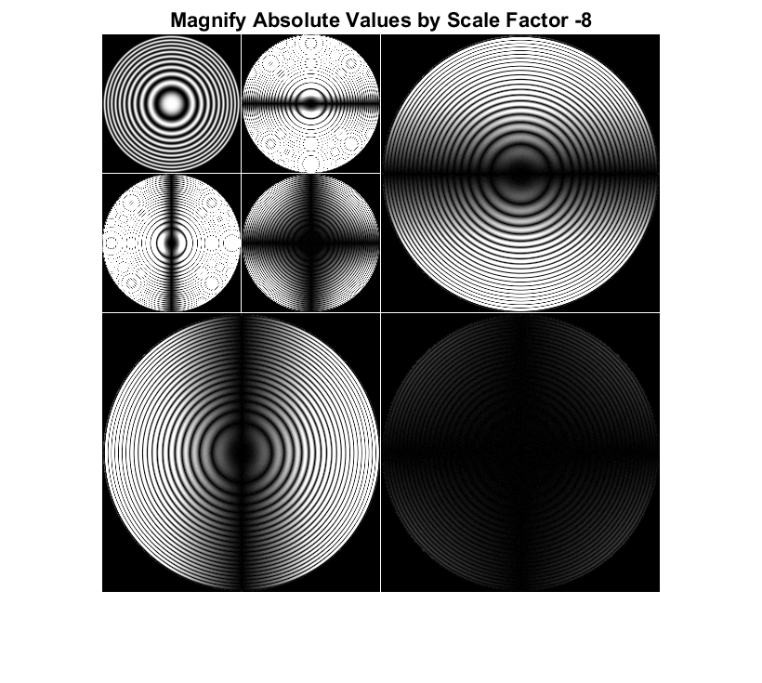

**Discussion**

(a) Default Setting (No Scale): Displays the coefficients without any magnification and provides a standard representation of the wavelet decomposition.

(b) Magnified by Scale Factor (scale = 8): Enlarges the coefficients by a factor of 8 and enhances fine details and highlights small-scale variations in the image.

(c) Magnify Absolute Values by Negative Scale Factor (scale = -8): Magnifies the absolute values of coefficients by a factor of 8 and emphasizes the magnitude of coefficients while potentially revealing features with both positive and negative values.

**Problem 3**

1. horizontal, vertical, and diagonal of the original image

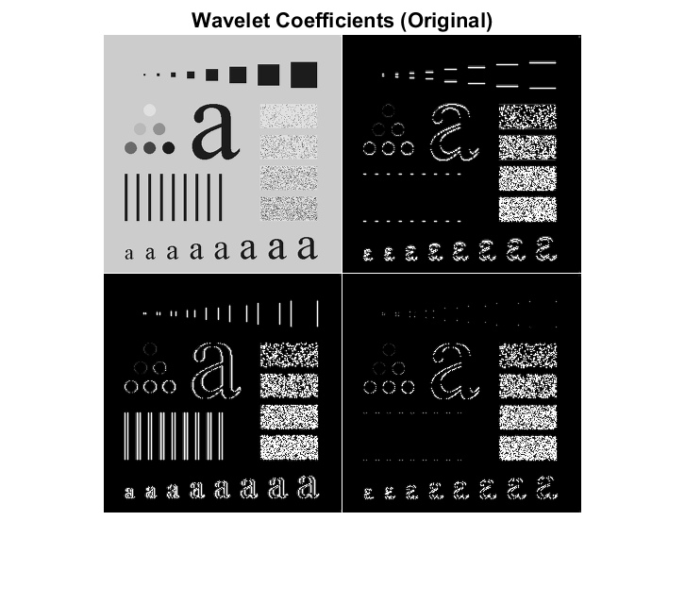

(b) 理論上應該有些係數被捨棄，不過肉眼上似乎看不太出來問題

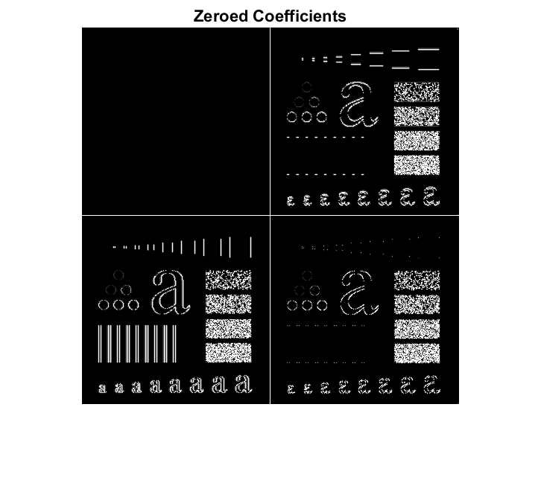

(c) 可看到幾乎只剩下影像邊緣的部分被留下來，效果有如高通濾波。

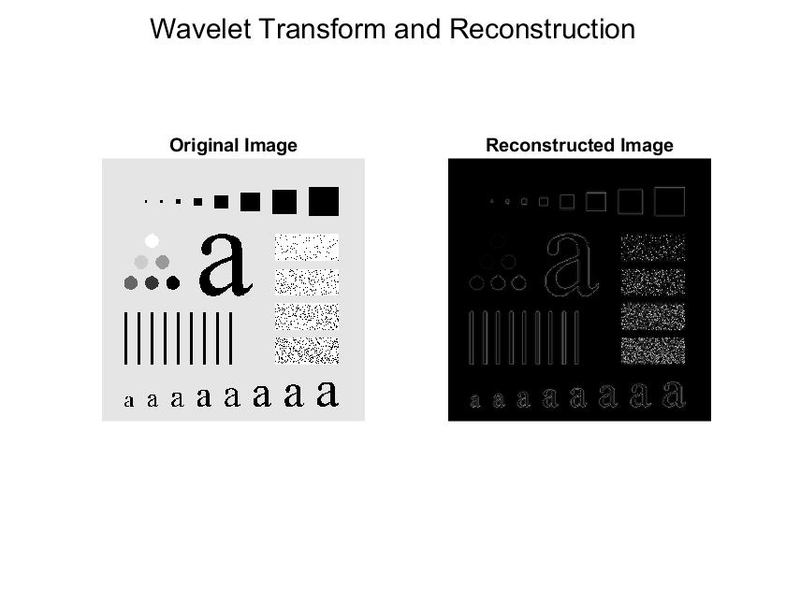

**Problem 4**

(a)

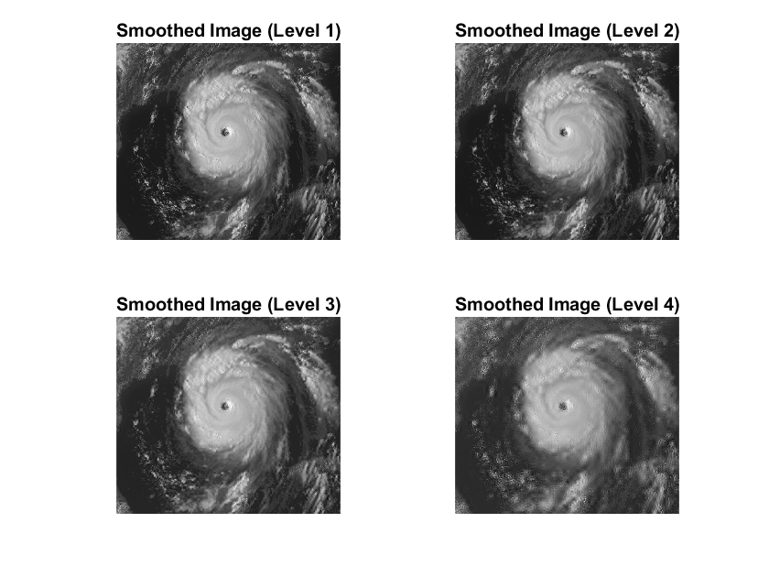

(b)

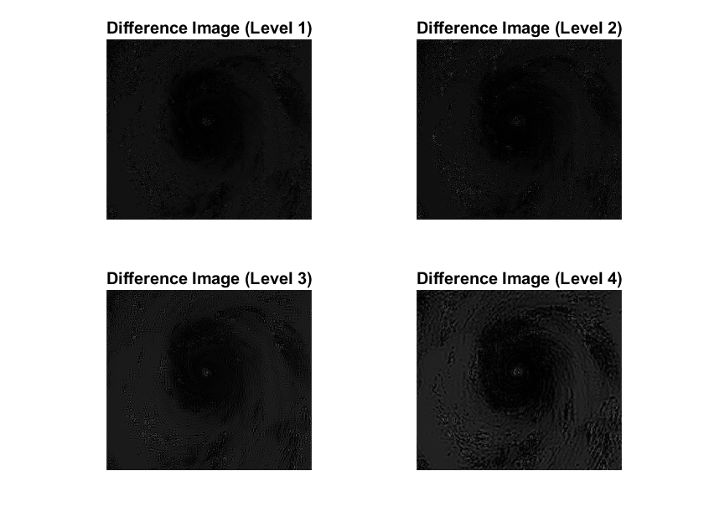

(c)

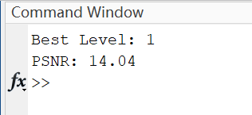

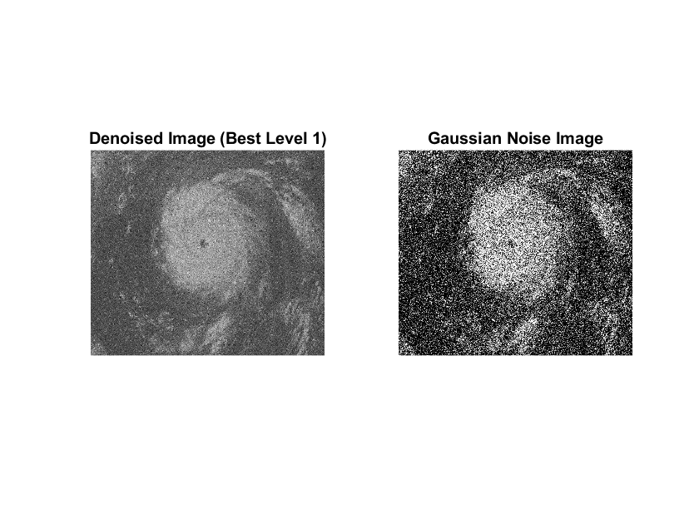

**Problem 5**

Coefficient:

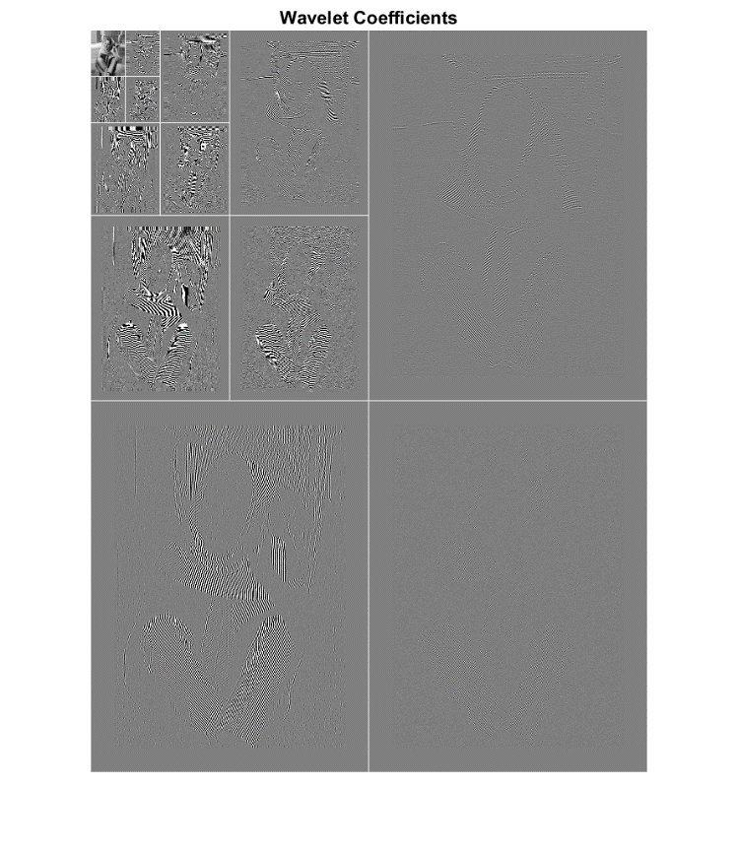

(a)

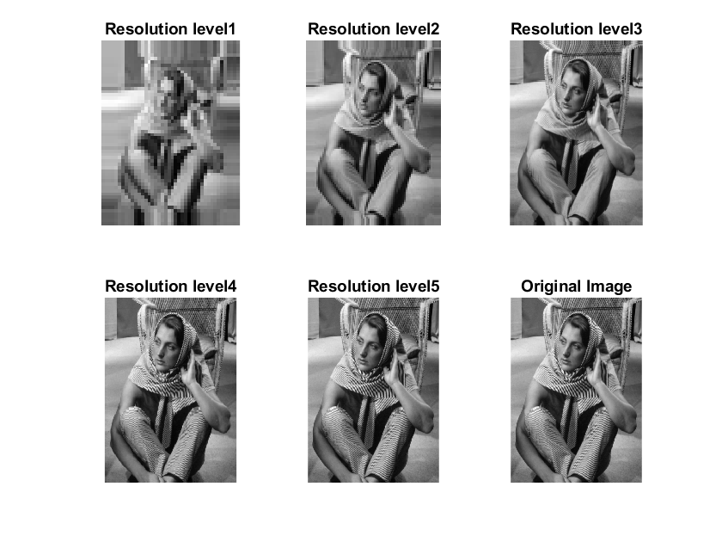

(b) 兩張圖片相同

